Input.data

MUFFLER 500 650 20  
brakes 130.50 430 15  
Wheel 130 160 3  
engine 1300 1600 2  
Mirror 12.50 30.50 5  
Rims 140.50 160.00 5  
Bumper 305.30 405.15 1  
Door 350.60 600.50 3  
Fender 120.00 150 3  
Glass 18.50 30.20 3  
Windshield 150.75 320.15 6  
sunroof 12.50 16 3  
Motor 1499.69 1850.30 3  
Radiator 1780.50 1900.0 1  
AirFreshner 12.50 15.50 10  
SparkPlug 1980.40 2000.00 7  
indicator 150 180 8  
Fuse 10 20 5  
Seat 160 190 5  
lock 300 400 4

Output.out

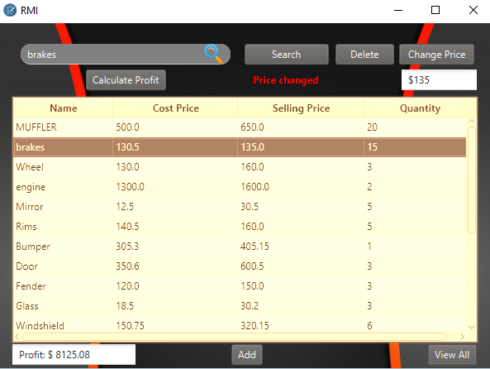

Command 2

Command 3

Command 4

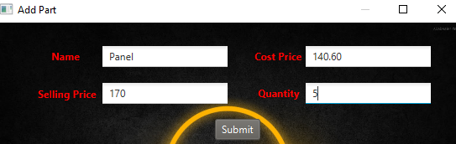

Extra Feature

Command 5

Command 1